Using stxmsort

One thing to be careful of! While it will not delete any files, if the script doesn’t recognize it as a scan or stack it will move it into the “LocatingFiles” folder that it makes. This means if you had any images or text files or whatever, they will get moved as well. Not a huge deal but something to keep in mind.

First organize all of the raw data into labeled folders like this:

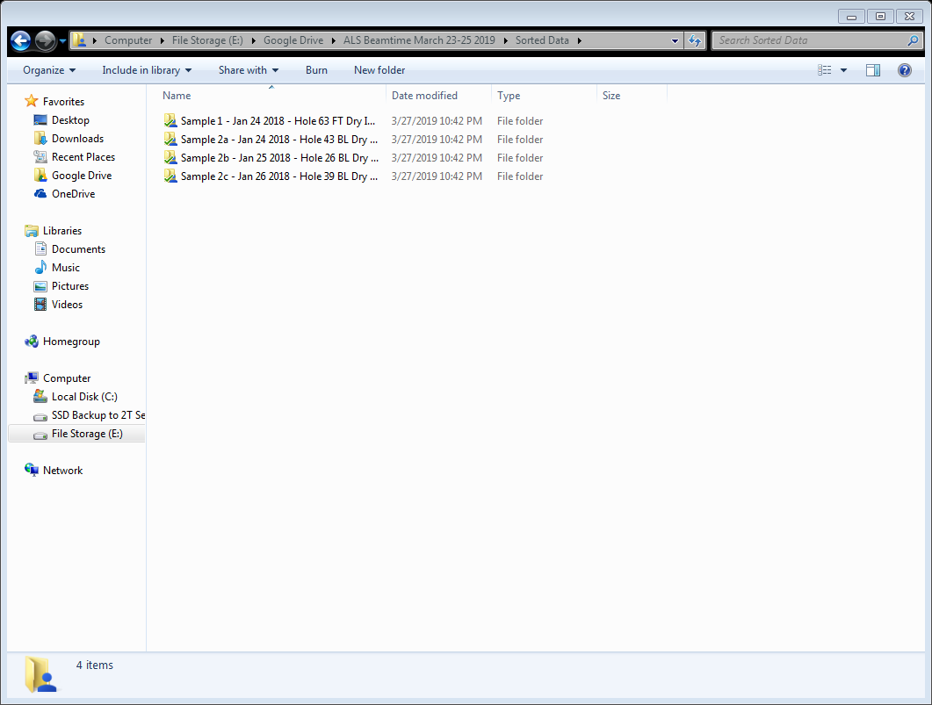

Where in each of those folders you have something like this (folders are stacks and the loose images are single energy images, usually locating scans):

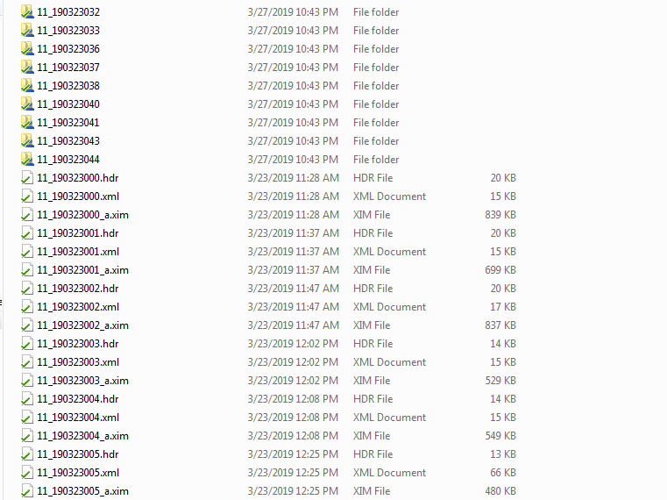

Once you run stxmsort you see a window like this and you navigate to the folder with the raw data sorted into labeled folders:

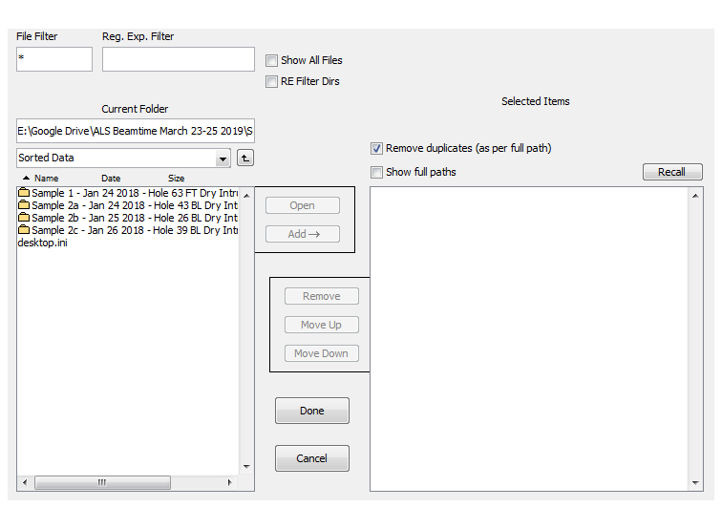

Select each folder and press “add” (or select them all with ctrl+click or shift+click) so you see this:

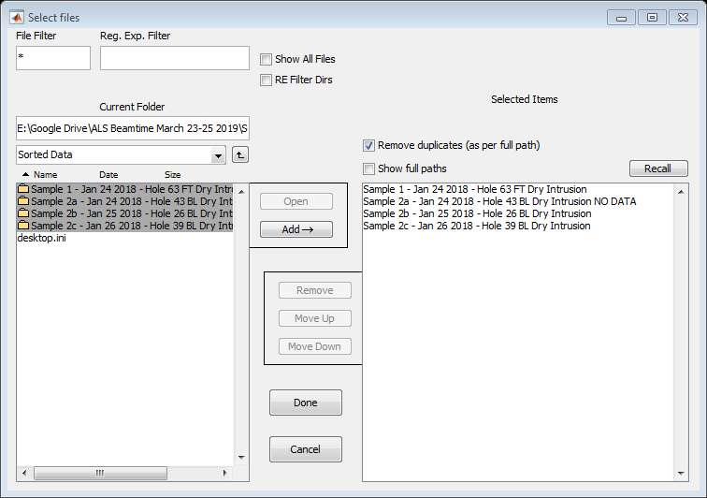

Then press done and now each of those 4 labeled folders selected above now look organized:

